Network analysis

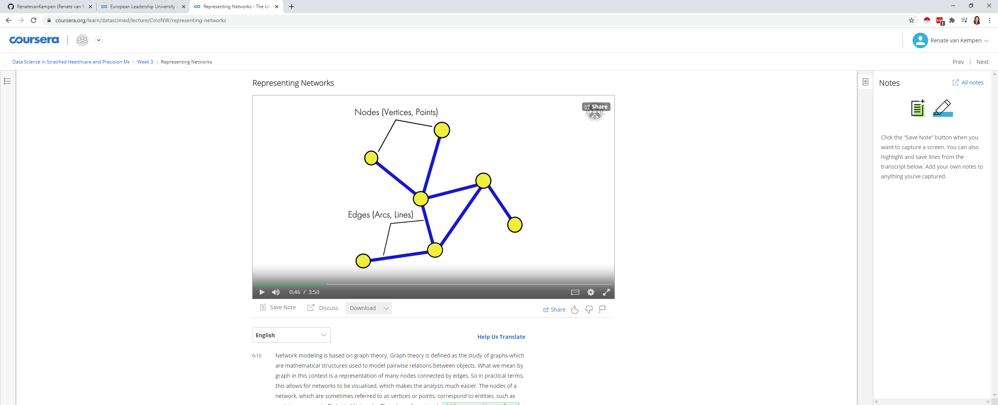

The nodes of a network,

which are sometimes referred to as vertices or points,

correspond to entities, such as proteins or genes in Biological Networks.

The edges of a network,

which are sometimes referred to as arcs or lines,

reveal information about the connections between the nodes.

# Undirected Graph



An undirected graph is a graph in which edges have no orientation or direction.

The relationship between the nodes is simple connection

The edges indicate a two-way relationship, in that each edge can be bi-directional.

Undirected graphs are commonly found in protein to protein interaction networks.

# Directed Graph



A directed graph is a graph in which edges have

orientation or a direction associated with them.

The edges indicate a one-way relationship

in that each edge can only go in a single direction

Directed graphs are mainly found in metabolic,

signal transduction or regulatory networks.

# Weighted GRaph



Weighted graphs are graphs in which each edge is

given a numerical weight or quantity value.

Such weights might represent, for instance,

sequence or structural similarities between proteins or co-expression of genes.

Weighted graphs can have either directed edges,

one-way relationship or undirected edges, two-way relationship.

# Adjacency Matrix

An Adjacency matrix is a data structure used to store network graph representations.

The values of the Matrix indicate whether

pairs of nodes are adjacent or not in the graph.

## Undirected graph - matrix

its adjacency matrix is simply represented

by a symmetric matrix containing only the values one and zero.

These values simply indicate the presence or absence of connections respectively.

## directed and weighted graph – matrix

These can use different numerical values in the matrix to illustrate this.

These values are sometimes used to indicate stimulation or inhibition within a network.

The way in which nodes and edges are arranged within a network is down to its topology.

Topological properties can help to identify relevant sub-structures within a network.

# Types of Biologic networks

## protein-protein interaction network

A protein-protein interaction network is an undirected graph where

nodes represent proteins and edges represent the interactions between the proteins.

Protein-protein interactions are crucial to nearly every process in a cell.

So, understanding protein-protein interactions will provide

a better understanding of cell physiology in normal and diseased conditions

## metabolic networks

Metabolic networks are directed graphs where

each node represents a metabolite or a molecule,

and edge represents a metabolic reaction

This type of network has metabolites and enzymes for

nodes and directed edges connecting the reactions

Metabolic networks can be used to analyze

an organism's growth, reproduction and its responses to an environmental change.

An example of metabolic networks in disease is type 2 diabetes

## genetic interaction networks

Genetic interaction networks show

the functional relationship between different genes and not a physical relationship.

This is because a genetic interaction between two genes generally reveals

the phenotype of a double mutant to be

different from what is expected from each individual mutant.

In a genetic interaction network,

genes are represented as nodes and the relationship as edges.

The direction of the edge is dependent upon the type of evidence behind the interaction

## gene or transcriptional regulatory networks

A gene or transcriptional regulatory network

represents how gene expression is controlled.

More specifically, it is a set of genes or parts of

genes that interact with each other to control a specific cell function.

With this type of network, genes and transcription factors are represented as nodes,

whereas the relationship between them is

illustrated by different types of directional edges

## cell signaling networks

Cell signaling is the communication process that

control cell activity and coordinates all cell actions.

Elements in cell signaling networks such as proteins or metabolites are

represented as nodes and the flow of information is represented by directed edges

errors in cell signaling may cause diseases such as cancer.

Therefore, by analyzing and understanding cell signaling,

diseases may be treated more effectively

# Cancer Systems Biology

An example of network analyses playing an important role in precision medicine

is Cancer Systems Biology.

Cancer Systems Biology is the application

of Systems Biology approaches to cancer research.

This means the analysis of

how intracellular networks of normal cells become cancer cells.

The analysis of this data can determine

effective protective models that can assist the production of new therapies and drugs